**MEHAK RAFIQ**

**BS-II ZOOLOGY (M2)**

**Genetic Engineering:**

Genetic Engineering is the technique of biotechnology which helps in preparing recombinant DNA. DNA molecule is cut into small pieces in in vitro environment. There are numerous techniques which have been used in genetic engineering for example, recombinant DNA technology, microinjection, bioballistics, electro and chemical poration.   
  
**Techniques:-**  
  
**Recombinant DNA:-**  
  
Following steps are involved in recombinant DNA technique;  
  
1) Gene of interest is isolated from the DNA molecule using the restriction enzymes.  
2) After isolation, gene is inserted into a vector and is cloned to make multiple copies of gene of interest.  
3) When the cloning is done, the gene is incorporated into the plasmid.  
4) Now the gene or DNA along with the plasmid is called as recombinant DNA.  
  
Plasmids and vectors used for the recombinant technique are usually bacteria or viruses. They have the ability to carry foreign genes into the host cell where they release the gene of interest and this gene replaces the diseased gene.   
  
**Electro and chemical portion:**  
In this method, pores are created in the membrane of the cell and genes can be transferred easily. Special chemicals are used to make pores in the cell surface. Sometimes cells are exposed to weak electric current, it also makes pores in the surface of the cells and genes can easily pass through these pores.  
  
**Bioballistics method:**  
In this method, small silver particles are used to insert the genetic material into the recipient cell. These silvers are coated with the genetic material and when released in the cell, genetic material incorporates with the genes of the host cell. In one projectile method, shot gun is used to insert the silvers into the host cell.   
  
**Microinjection:**  
It is not necessary that only plasmids and vectors should be used for the transfer of genes into the cells. There are methods which are not dependent on plasmids and vectors. One of these methods is microinjection. In this method, foreign gene is integrated into the cell by just injecting it into the recipient cell. When large cell of plants and animals are concerned, then a fine glass needle is used. The injected genes automatically enter into the nucleus where they incorporate with the host cell’s genetic material and replicate.

**DNA Microinjection:**

In DNA microinjection, also known as pronuclear microinjection, a very fine glass pipette is used to manually inject DNA from one organism into the eggs of another. The best time for injection is early after fertilization when the ova have two pronuclei. When the two fuse to form a single nucleus, the injected DNA may or may not be taken up. The University of California (Irvine) [Transgenic Mouse Facility](http://www.research.uci.edu/tmf/dnaMicro.htm) reports an estimated 10 to 15 percent success rate based on mice testing positive for transgenes in their experiments). If the DNA is incorporated into the genome, it is done so randomly. Because of this, there is always a chance the gene insert will not be expressed by the [GMO](https://www.thebalance.com/what-are-gmos-375532), or may even interfere with expression of another gene on the chromosome.

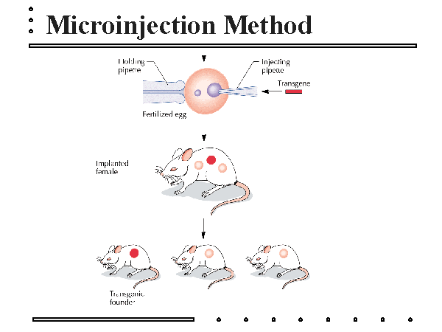

Following DNA injection, the ovum is transferred into the oviduct of a recipient female, or foster mother, that has been induced by mating with a vasectomized male.

## Vectors:

## Vector are usually viruses which are also helpful in genetic engineering. Virus is an infectious organism, so when a new gene is inserted in it, it transfers that gene into the host cell during causing infection. Scientists mostly block the function of virus when they insert the foreign gene; this way virus will only be able to replicate only the gene of interest and will insert it into the host cell.

## Method to Move a Vector into a Host Cell:

The process of transferring genetic material on a vector such as a plasmid, into new host cells, is called transformation. This technique requires that the host cells are exposed to an environmental change which makes them "competent" or temporarily permeable to the vector. [Electroporation](https://www.thebalance.com/tools-for-protein-engineering-375522) is one such technique. The larger the plasmid, the lower the efficiency with which it is taken up by cells. Larger DNA segments are more easily cloned using bacteriophage, retrovirus or other viral vectors or cosmids in a method called transduction. Phage or viral vectors are often used in [regenerative medicine](https://www.thebalance.com/pros-and-cons-of-stem-cell-research-375483) but may cause insertion of DNA in parts of our chromosomes where we don't want it, causing complications and even cancer.

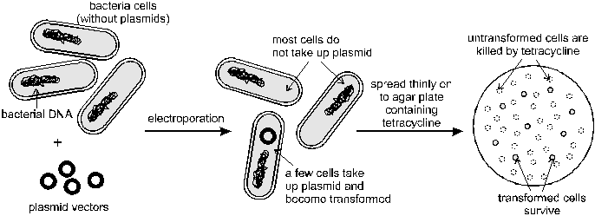

**Vector properties:**Vector is the carrier molecule which is used in genetic engineering in order to transfer our gene of interest into the host cell where it will be expressed. There are a lot of reasons for this action ranging from the study of gene expression to the production of needed proteins. Once the vector has accepted our DNA of interest, it becomes a recombinant molecule.  
  
There are several characteristics which are important for the vector molecule in order for it to be efficient and worthy of using in genetic engineering.  
  
**Size matters:**  
It is very important that vectors are small molecules (relatively speaking), because this way it will be a lot easier to insert them into the host cell, making the whole process of transformation (insertion of vector molecule into the competent host cell) a lot more efficient.  
  
**Reproducibility:**  
It has to have an origin of replication. This is the region on the DNA that will be recognized by the protein complex responsible for the initiation of transcription. Without the origin of replication, our gene of interest will not be expressed in the host cell.

**Selectable marker:**  
The process of transformation in not very efficient (depending on the approach), so if we are working with the certain amount of bacterial cells that we want to transform, not all of them will accept our vector (and gene of interest). In fact, probably most of them won’t. How can we know which cells have our vector inside? It is simple - by using vectors with selectable markers which will help us distinguish the cells that have successfully transformed from the ones that haven’t. For example, we can use a certain vector molecule which has the gene for ampicillin resistance in it. Then we can grow the cells in the cell culturing medium which contains the ampicillin. Only the cells that are transformed successfully will be able to grow in the medium, because we will eliminate all of the other ones in a simple and effective way.  
 **Target sites:**  
How can we insert our gene of interest into the vector molecule? We can accomplish this by using restriction enzymes which cut the DNA at specific places. These places are called target sites and they are usually short, palindromic sequences compatible only with specific restriction enzymes. Once they cut the DNA, our gene of interest can be inserted and sealed in the vector molecule using the enzyme ligase,

**Plasmid:**

plasmid is a circular piece containing the genetic material. When new gene is inserted in it, it opens it ring and new gene is attached to its ends through the enzyme called as ligase. New gene replicates along with the plasmid’s genetic material. For example if plasmid is carrying a gene of insulin, t will start producing the protein of insulin along with other gene products. Bacteria are of great significance in the pharmaceutical industry because they are used to produce insulin and other useful proteins.

**Plasmid types**  
This is the division relevant to the genetic engineering and transforming target cells. There is also another division of plasmids according to their function (like resistance plasmids, degradative plasmids, virulence plasmids, etc.), but this is not really important for the subject, so I won’t cover it here.

**Low-copy number plasmids**:  
The main feature of these plasmids is that they replicate in low numbers in host cell. This enables the metabolism of a host cell to stay at low level, enabling the cell to reproduce moderately. They are easily constructible and they can be used to study genes in basic metabolic pathways, or to clone genes whose overexpression can kill the cell. They are also known as stringent plasmids, as their replication is “bounded” to, or limited by the replication of the host cell DNA.  
  
Subtype of low-copy plasmids are runaway plasmids. They are sensitive to temperature and their expression (replication) remains low in the optimum temperature. If the temperature increases too much, they get overexpressed, which results in the death of the cell.  
  
**High-copy number plasmids:**  
Opposite from low-copy number plasmids are high-copy number plasmids. The name tells for itself – they are able to replicate in high numbers after they enter into the host cell. They are also known as relaxed plasmids, because they are not limited by the replication of the host cell DNA. They can be used for the production of a certain protein which is needed in high ammount.  
  
**Conjugative plasmids:**  
These plasmids contain mob (mobilizing) and tra (transfer) genes which help them transfer to the bacteria on their own. Tra genes are responsible for the formation of F-pilus – a bridge between two cells through which the plasmid can transfer itself. They usually have high molecular weight and they replicate only into few copies (1 to 3 per cell). Example of conjugative plasmids is F-plasmid.  
  
**Non-conjugative plasmids:**  
These plasmids are the opposite of conjugative plasmids. They do not contain mob or tra genes and are therefore incapable of initiating the process of conjugation, so they need help from conjugative plasmids in order to be transferred. They have low molecular weight and they usually exist in multiple copies per cell.

**Mobilizable plasmids**:  
These plasmids are somewhere in between of conjugative and non-conjugative ones, because they contain mob genes, so they can use conjugative plasmids in order to transfer to other cells.

**Gene cloning** :

Gene cloning is the act of making copies, or clones, of a single gene. Once a gene is identified, clones can be used in many areas of biomedical and industrial research. Genetic engineering is the process of cloning genes into new organisms, or altering the DNA sequence to change the protein product. Genetic engineering depends on our ability to perform the following essential procedures.

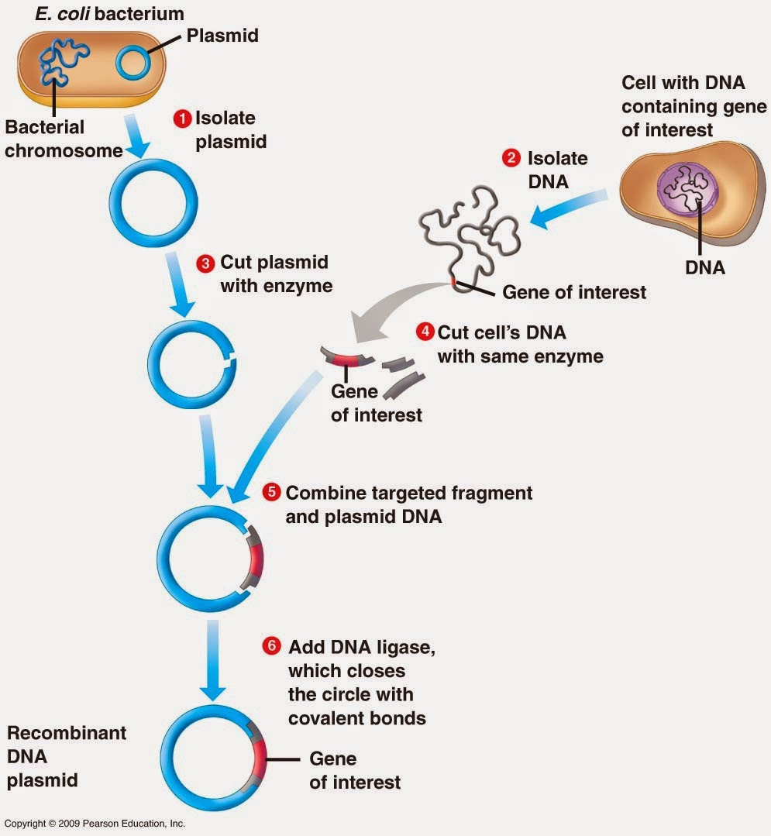

**Polymerase Chain Reaction :**

The discovery of thermostable DNA polymerases, such as Taq Polymerase, made it possible to manipulate DNA replication in the laboratory and was essential to the development of [PCR](https://www.thebalance.com/what-is-polymerase-chain-reaction-pcr-375572). Primers specific to a particular region of DNA, on either side of the gene of interest, are used, and replication is stopped and started repetitively, generating millions of copies of that gene. These copies can then be separated and purified using gel electrophoresis.

**Electrophoresis:**

Purifying DNA from a cell culture, or cutting it using restriction enzymes wouldn't be of much use if we couldn't visualize the DNA - that is, find a way to view whether or not your extract contains anything, or what size fragments you've cut it into. One way to do this is by [gel electrophoresis](https://www.thebalance.com/how-to-make-tbe-buffer-in-3-easy-steps-375493). Gels are used for a variety of purposes, from viewing cut DNA to detecting DNA inserts and [knockouts](https://www.thebalance.com/what-is-biotechnology-375751).

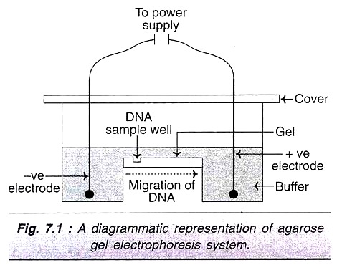

**Selection of Small Self-Replicating DNA:**

Small circular pieces of DNA that are not part of a bacterial genome, but are capable of self-replication, are known as plasmids. Plasmids are often used as vectors to transport genes between microorganisms. In biotechnology, once the gene of interest has been amplified and both the gene and plasmid are cut by restriction enzymes, they are ligated together generating what is known as a recombinant DNA. Viral (bacteriophage) DNA can also be used as a vector, as can cosmids, recombinant plasmids containing bacteriophage genes.

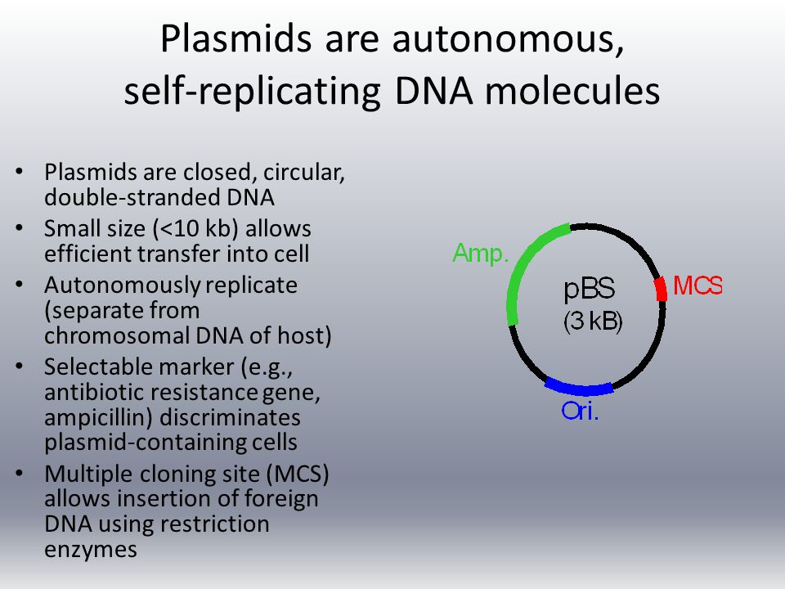

**Referene:**

http://www.biotechnologyforums.com/thread-43.html

https://www.thebalance.com/tools-for-protein-engineering-375522